# Application of Microservice Architecture to B2B Processes

(IBM Watson Customer Engagement)

*by*

**Arpit Jain**

## (2015047)

**Supervisor(s):**

|  |  |
| --- | --- |
| **External** | **Internal** |
| Mr. Atul A. Gohad  (IBM ISL, Bangalore) | Dr. Aparajita Ojha  (PDPM IIITDM Jabalpur) |



**Computer Science and Engineering**

**INDIAN INSTITUTE OF INFORMATION TECHNOLOGY, DESIGN AND MANUFACTURING JABALPUR**

## (21st August 2018 – 8th October 2018)

## Interim Review

# Introduction

The International Business Machines Corporation (IBM) is an American multinational [technology company](https://en.wikipedia.org/wiki/Technology_company) headquartered in [Armonk, New York](https://en.wikipedia.org/wiki/Armonk,_New_York), [United States](https://en.wikipedia.org/wiki/United_States), with operations in over 170 countries. IBM manufactures and markets computer [hardware](https://en.wikipedia.org/wiki/Computer_hardware), [middleware](https://en.wikipedia.org/wiki/Middleware) and [software](https://en.wikipedia.org/wiki/Computer_software), and provides [hosting](https://en.wikipedia.org/wiki/Internet_hosting_service) and [consulting services](https://en.wikipedia.org/wiki/Consultant) in areas ranging from [mainframe computers](https://en.wikipedia.org/wiki/Mainframe_computer) to [nanotechnology](https://en.wikipedia.org/wiki/Nanotechnology).

IBM aims to bring Businesses closer and smarter than ever with the help of their state of the art enterprise software product called B2B Sterling Integrator. IBM B2B Integrator helps companies integrate complex B2B (Business to Business) / EDI (Electronic Data Exchange) processes with their partner communities. IBM aims to transform the B2B Sterling product into Microservice architecture.

Brief Overview

Until now (Post Midterm review), I have completed several tasks pertaining to the B2Bi Sterling Integrator. Proceeding in stages, Firstly, I researched about the Java Spring-Boot microservice architecture and Web REST-API construction.

Secondly, I researched about IBM TenX framework. All the IBM B2B APIs are built using the IBM TenX framework only.

Thirdly, I learnt about deploying a sample SpringBoot application on the Sterling Integrator Liberty Server. Using this knowledge of Tenx and SpringBoot, I transformed two B2B APIs (originally Tenx based) namely User Accounts and UserVirtualRoot to SpringBoot framework. Then I deployed these new converted APIs on the same Liberty WebSphere server where the original B2B APIs were installed.

Now, that I had two implementations of the same set of APIs (Tenx and SpringBoot), I had to run the performance benchmarking against each other. Outputs of the performance testing were outstandingly good and are shown below in the next section. To experiment further and to be sure with the results, we flooded the server Database with a large number of objects to perform the extensive testing.

For the easy usage documentation of these new APIs, I added the Swagger Hub API Documentation dependency to the Spring Code.

Lastly, these new microservice spring-based APIs were lacking the UI front so I got myself acquainted to the Angular JS frontend framework. As a part of IBM internal hackathon, I developed a combined UI and a SpringBoot API Gateway (Secured using IBM w3id) in less than 24 hours.

Apart from my main work, as a part of the IBM XLence Program for IBM Interns, we just completed an end-to-end workflow of our deployment framework called DFRAME and gave a demo to the stakeholders and managers.

**Report on the Present Investigation**

(Progress until the Interim review)

Task 1: Researching about SpringBoot Architecture, IBM TenX Framework and deploying a sample SpringBoot application on Liberty server

A screenshot of a computer

Description generated with very high confidenceDuring this duration, I researched and developed a sample REST controller which returns Welcome message when a GET call to /hello URL is made. In this sample application, we have created a class HelloController and annotated it with @RestController which calls REST API and provides json response.

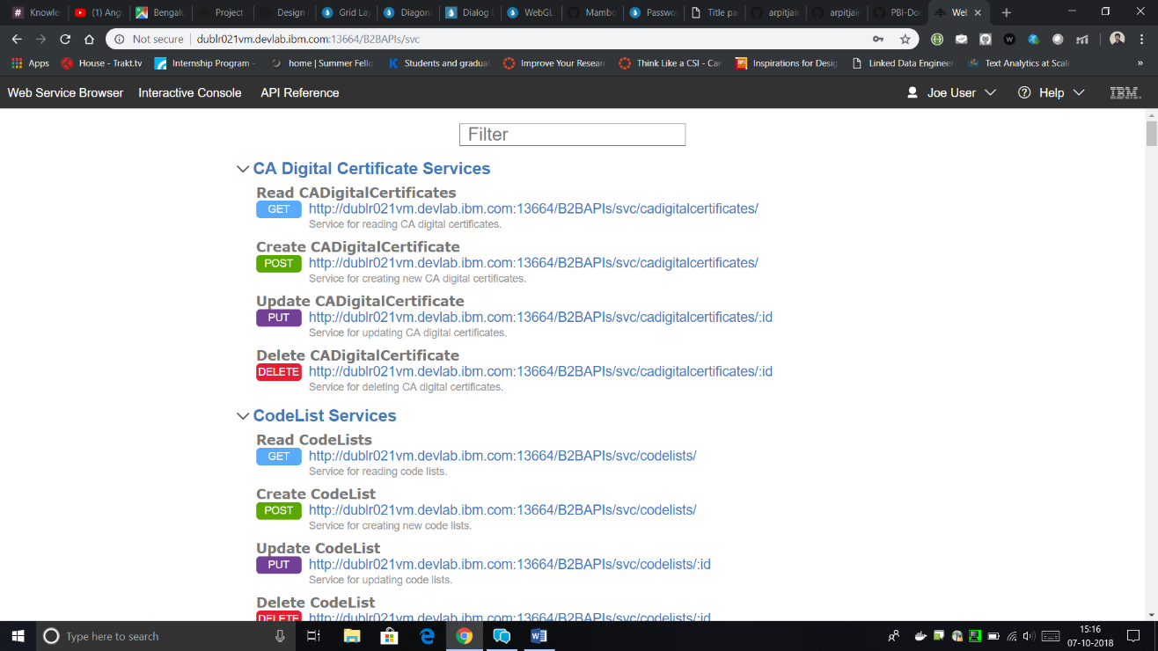(Sample Spring Boot API)

(TenX based B2B APIs)

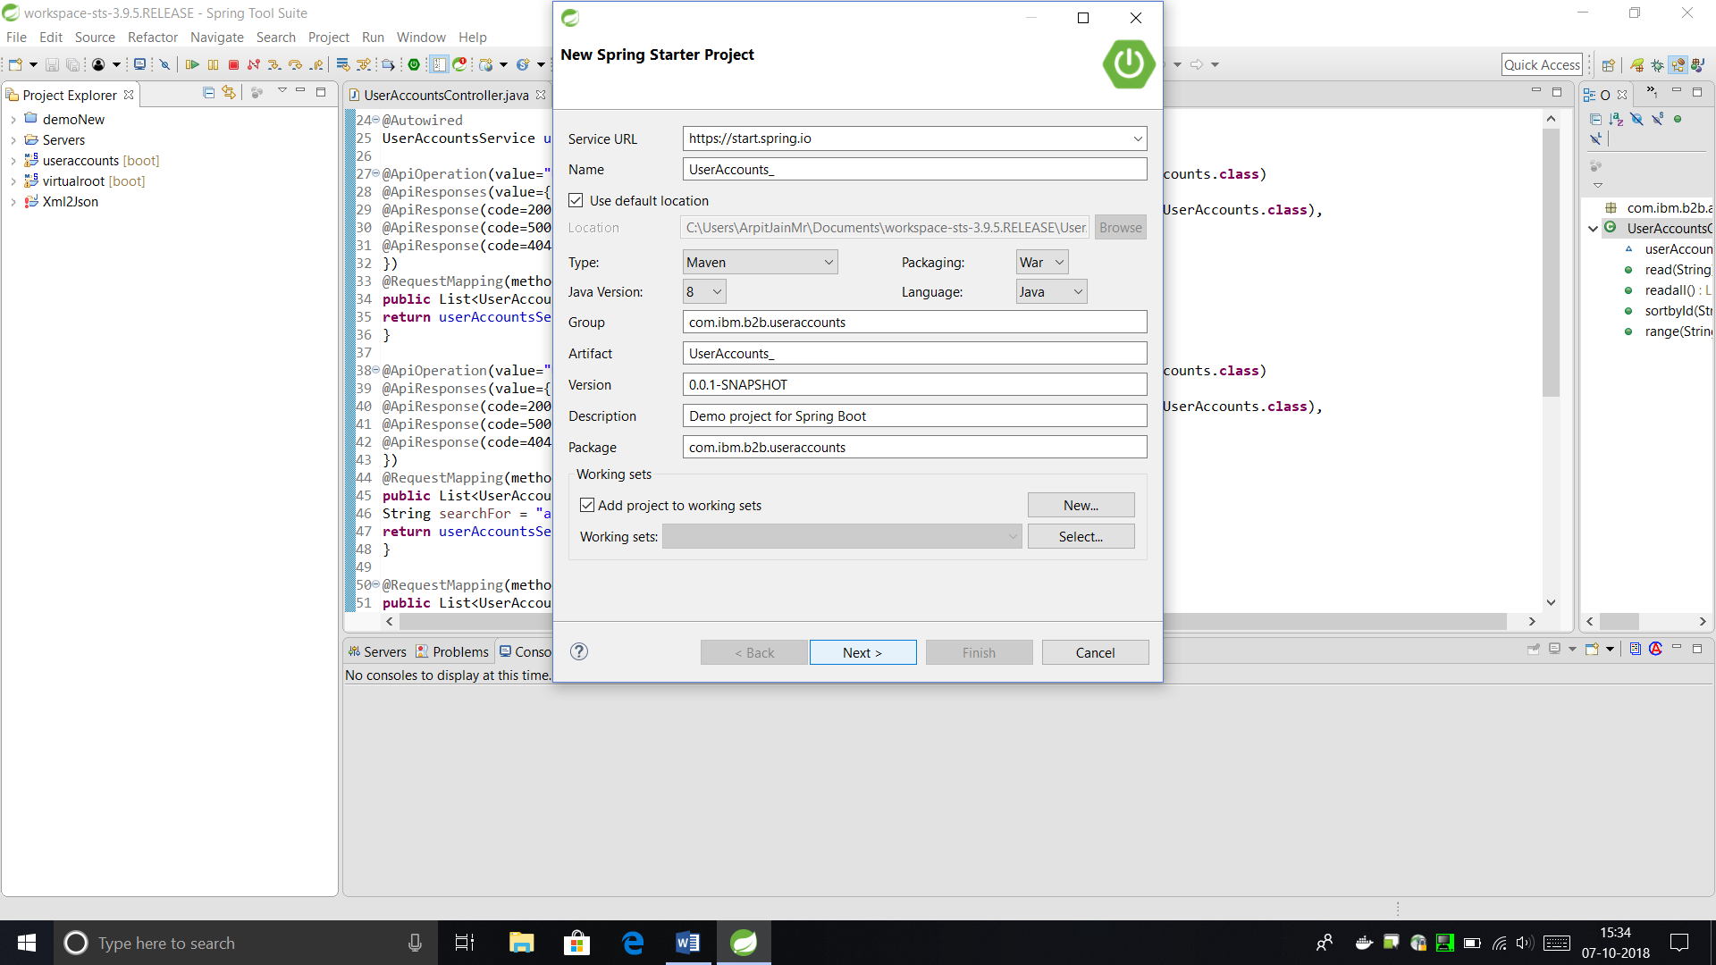Task 2: Converting UserAccounts and UserVirtualRoots APIs to SpringBoot

Conversion of UserVirtualRoots API to SpringBoot was explained in the last report. Here, I will cover the conversion of UserAccounts API.

This task required the following steps (demonstrated in detail in the last report).

1. Creating the Spring Starter project as shown in the previous picture.
2. Change the POM.XML dependency file for adding the dependencies.
3. Changing the code structure of Java Source files. (Tenx to Springboot format)

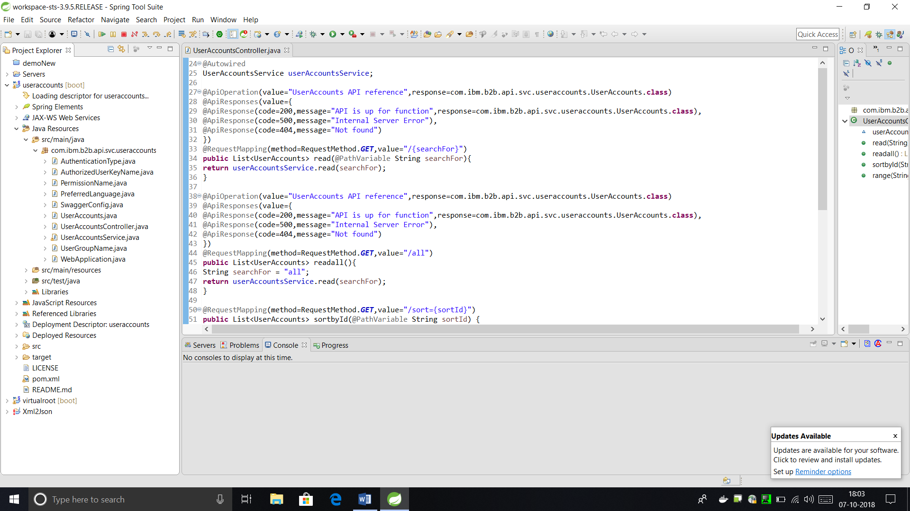

**Here, there are following classes –**

**(Code Cannot be revealed due to confidentiality clauses)**

* + **POJO Classes: Classes to represent the object entity structure.**

**UserAccounts.java**

**AuthenticationType.java**

**AuthorizedUserKeyName.java**

**PermissionName.java**

**PreferredLanguage.java**

**UserGroupName.java**

* + **Controller Class: This class is used to map the URL and Request Type to the respective Method Calls.**

**UserAccountsController.java**

* + **Service Class: This class is used to implement the actual functions for CRUD operations.**

**UserAccountService.java**

* + **Web Application Class: This class is used to start the SpringBoot.**

**WebApplication.java**

1. Package the Application as a WAR file using Maven Install

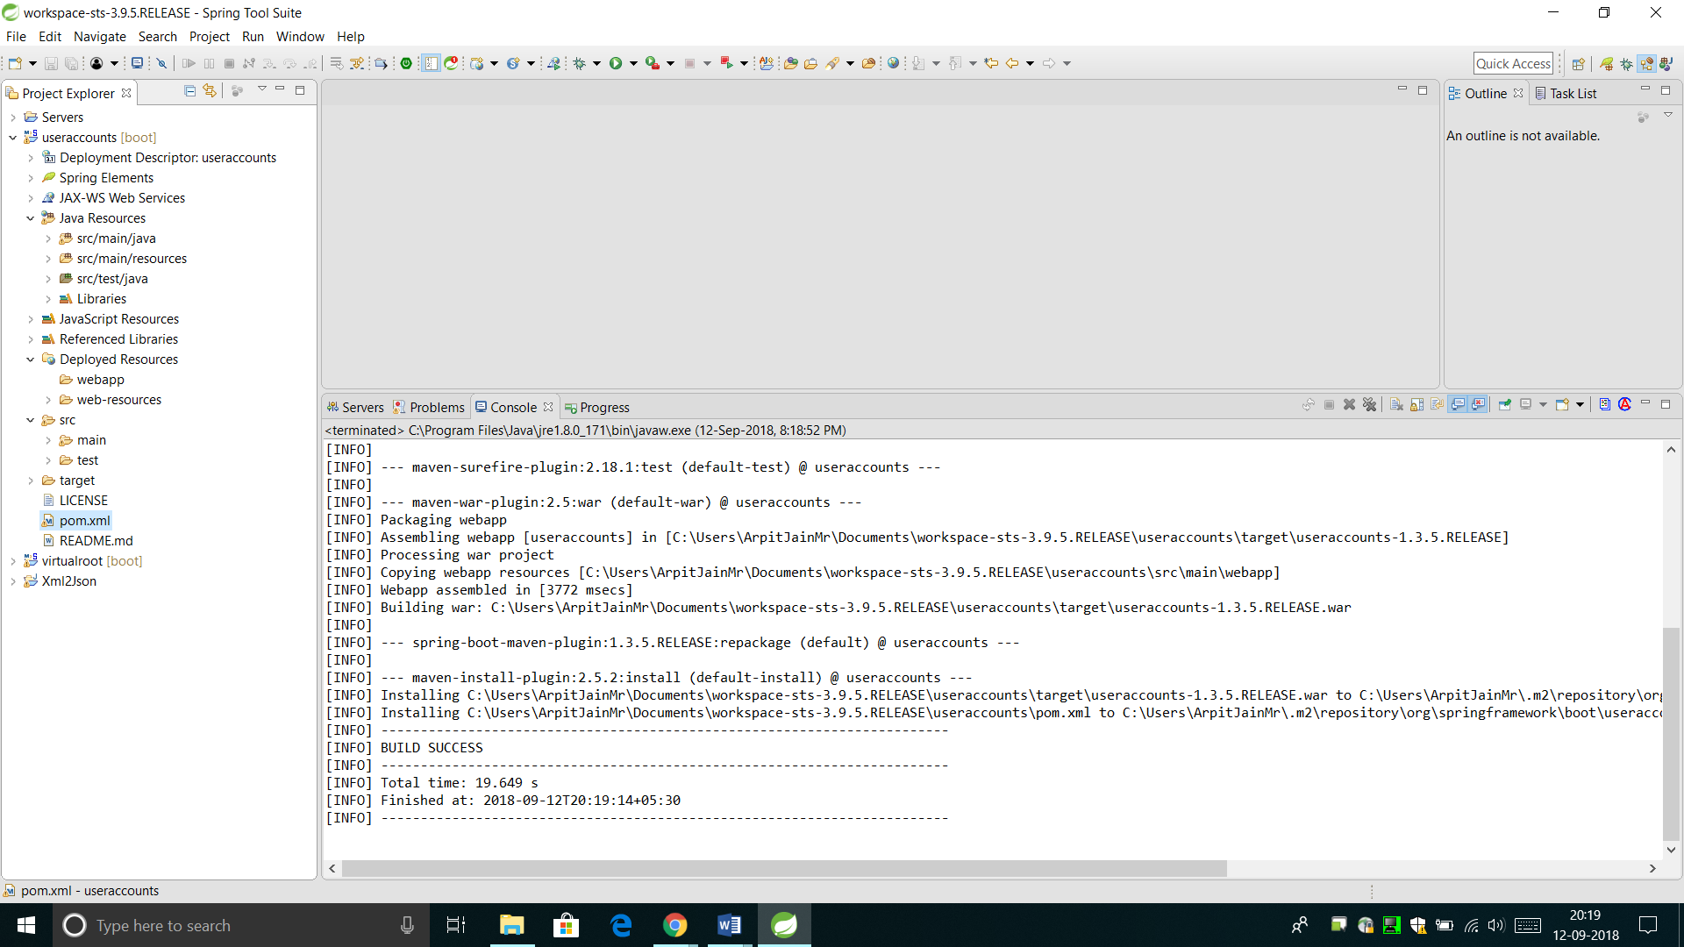

1. Deploy the File on the Liberty Server

* Copy the generated WAR file to the Liberty Server’s App directory.

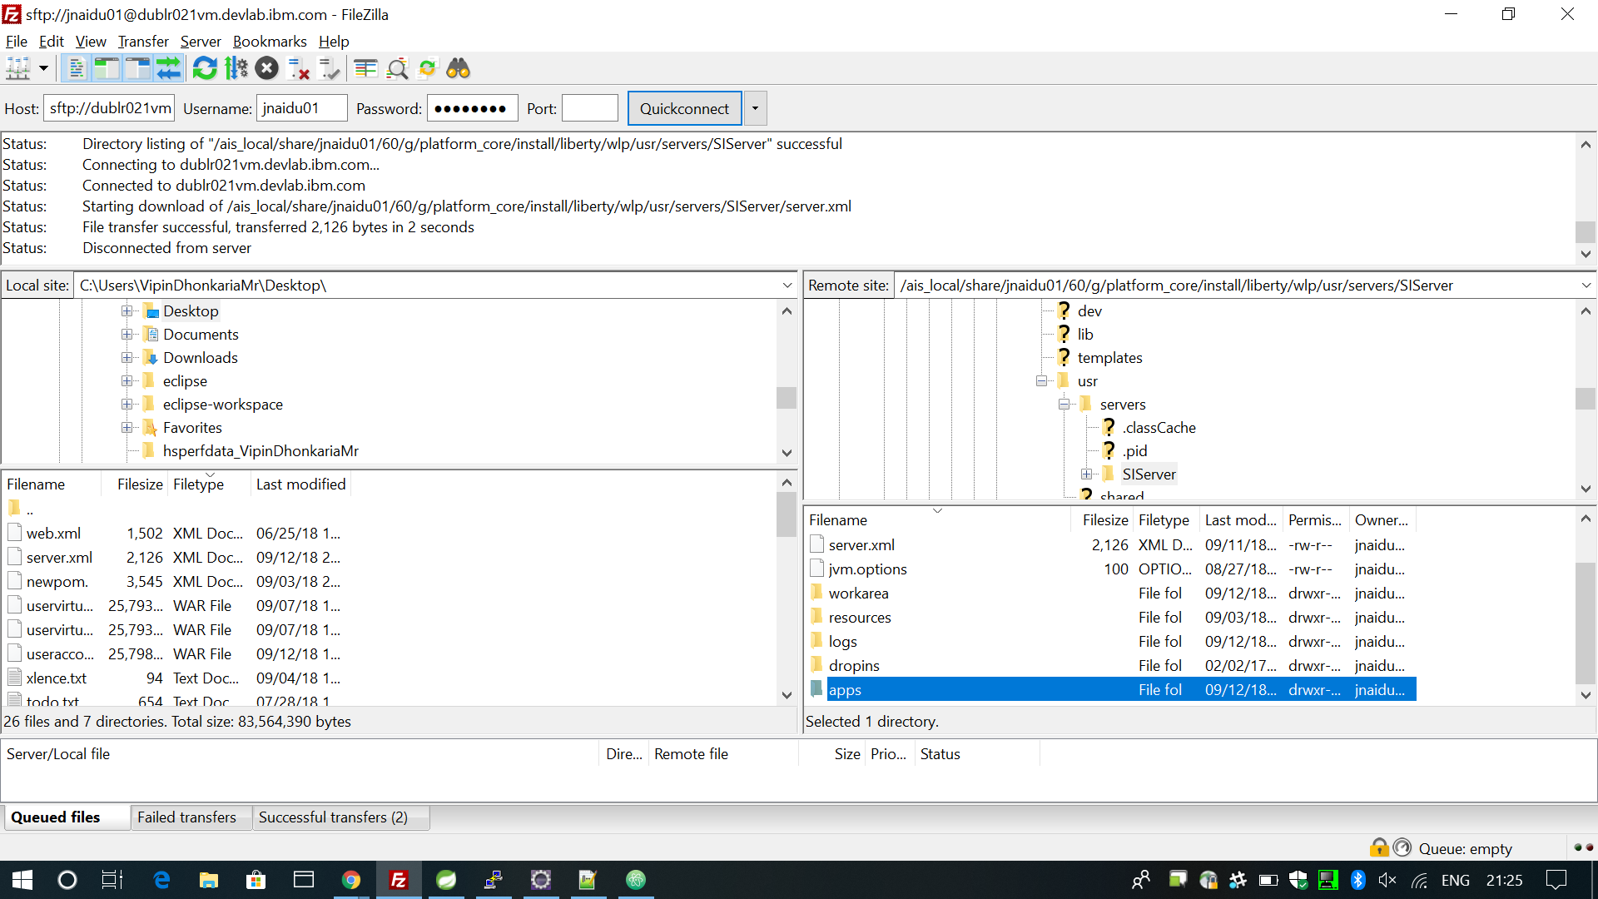

* Edit the server.xml file to add the External entry for Liberty to recognize your app WAR as an endpoint.

1. Restart the Server

* Run these Commands from the install/bin/ directory.

./hardstop.sh -> ./run.sh -> ./startLiberty.sh

1. Access the API on the specified URL

* 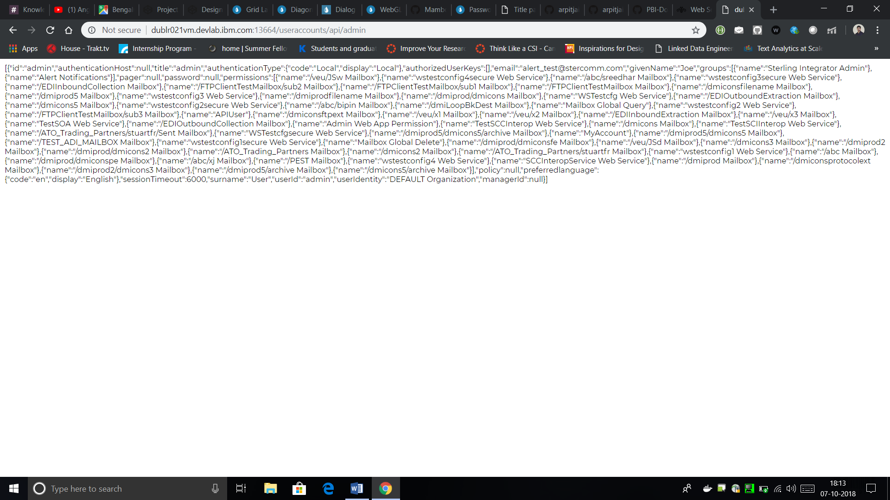Currently, it is just implemented for a Read Call.

Task 3: Performance benchmarking (TenX vs SpringBoot)

Aim of this benchmark was to compare the performance of using SpringBoot as a base B2B API framework against IBM Tenx API framework. The API which we picked for comparison was UserAccounts.

These tests have been done in two stages –

Case 1 : Sparsely populated DB of UserAccounts

Single-Read Request using TenX. (1507ms)

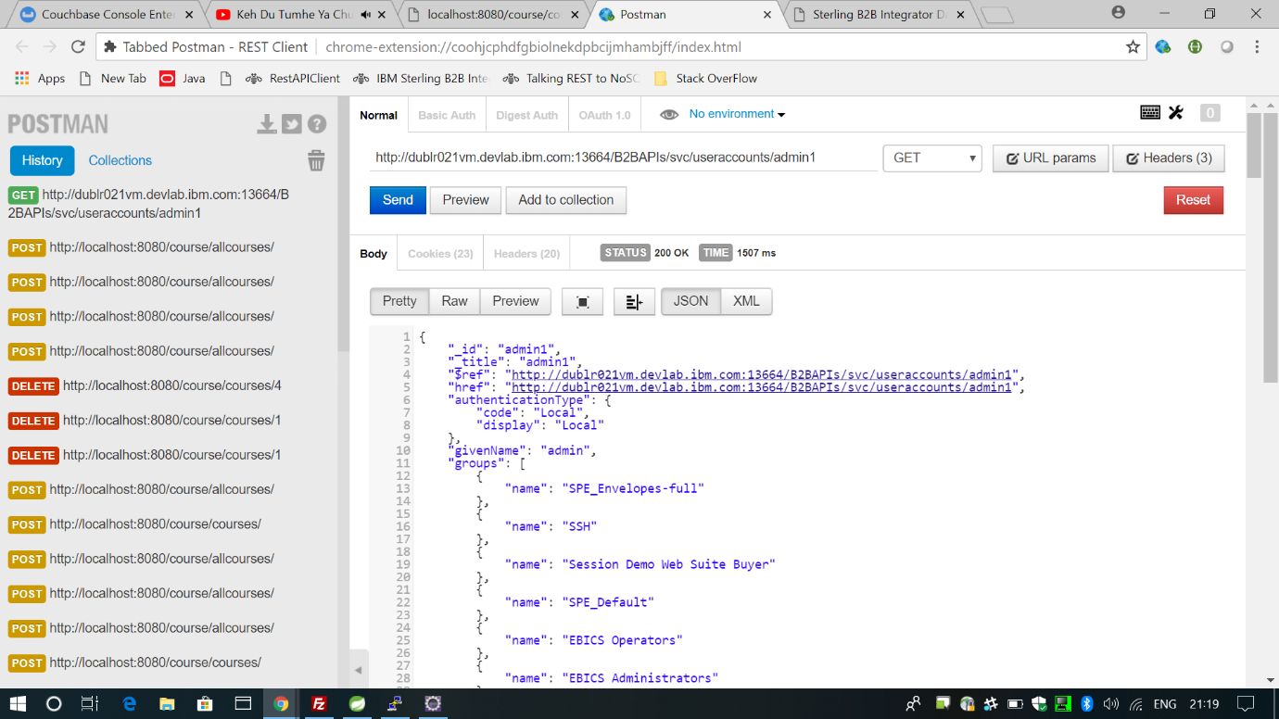

Single-Read Request using SpringBoot. (1210ms)

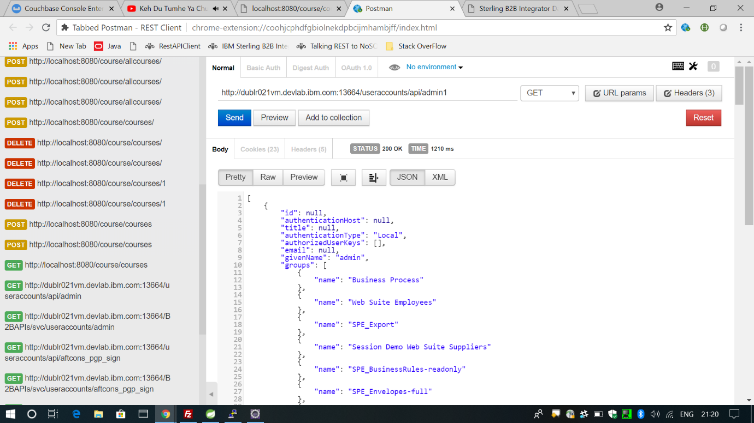

Case 2 : Densely populated DB of UserAccounts (10000 UserAccounts)

For performing extensive testing, we wrote a script that floods the UserAccounts Database by adding (sequentially posting) 10000 temporary User Accounts to the API endpoint.

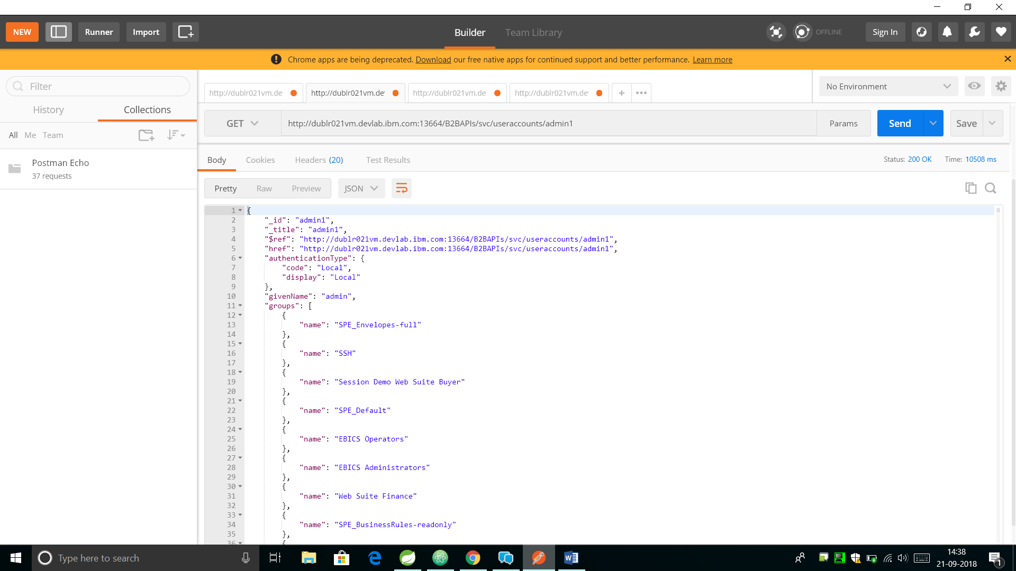Single-Read Request using TenX. (10508ms)

A screenshot of a computer

Description generated with very high confidenceSingle-Read Request using SpringBoot. (593ms)

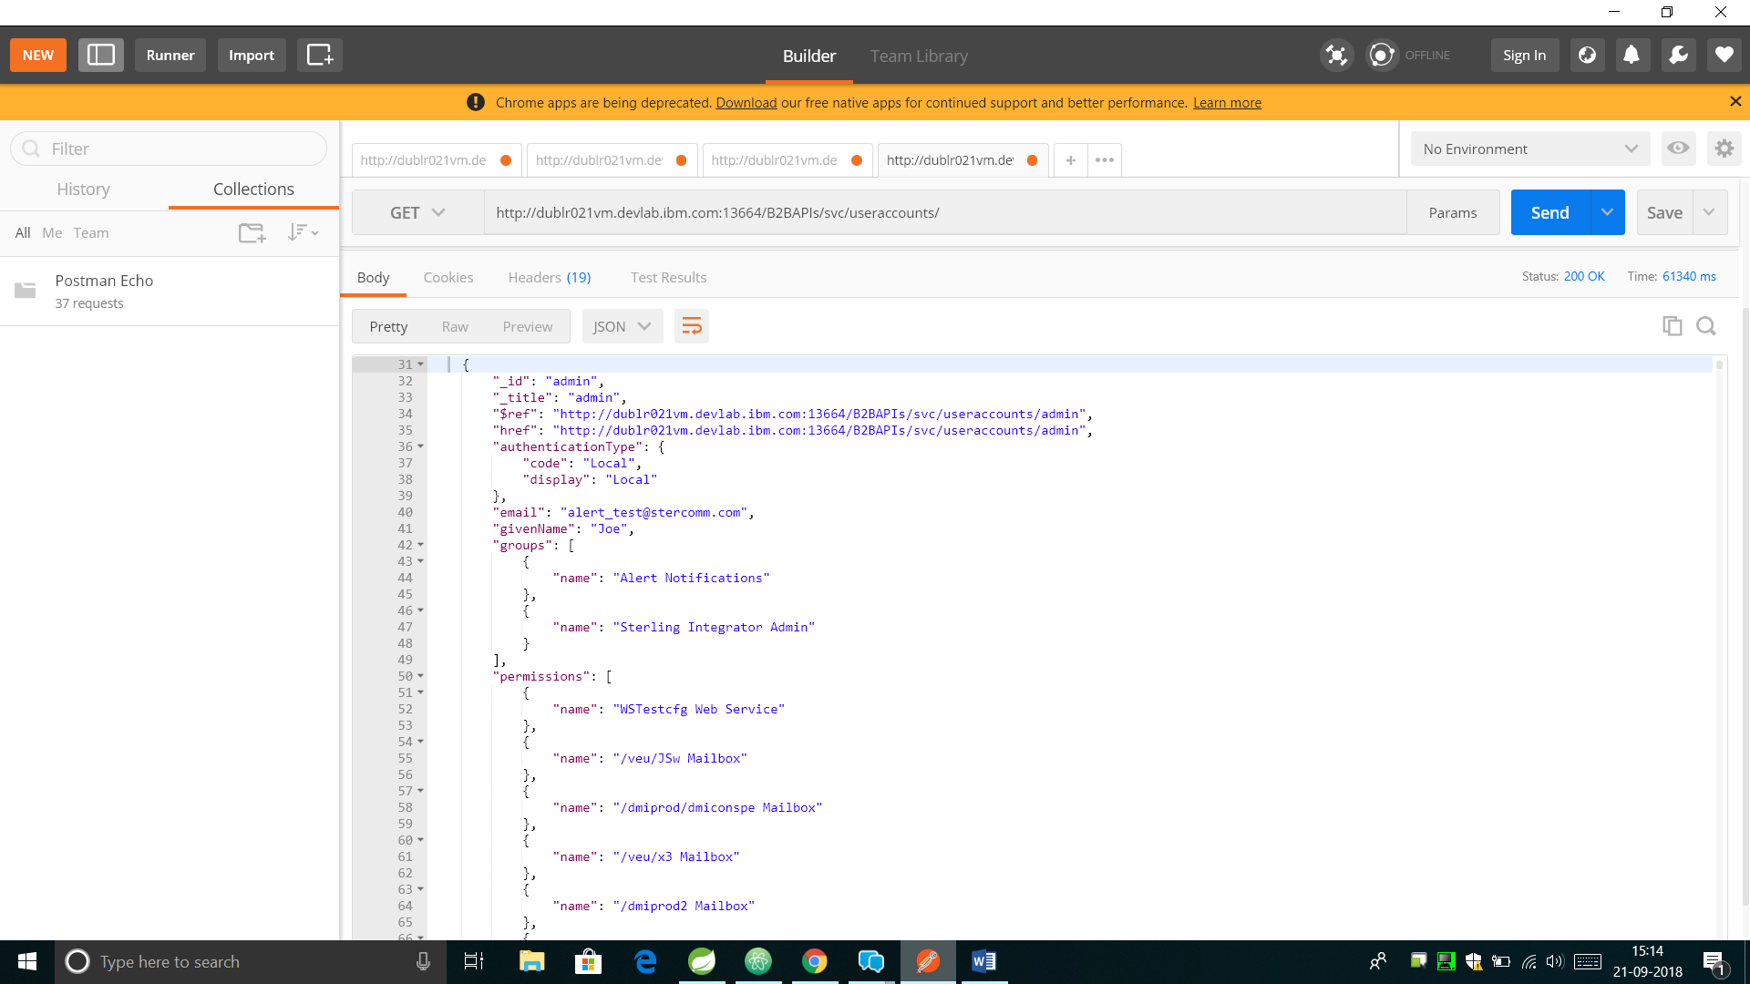Read-All Request using TenX. (61340ms, This Request fetches nearly 1000 records)

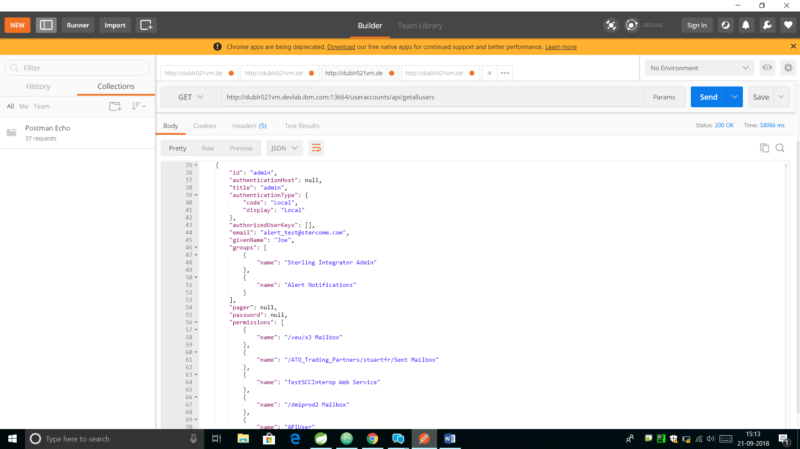

Read-All Request using SpringBoot. (58066ms, This Request fetches 10000 records)

Some Noteworthy Points

1. These tests have been performed on the same machine and on the same WebSphere Liberty server.
2. For Read-All requests, TenX only fetches maximum 1000 records.

Conclusions

1. In case of Sparsely populated DB, the difference between SpringBoot and TenX is not very drastic. (SpringBoot is nearly 200-250ms faster).
2. In the case of Densely populated DB, the difference is huge.
3. Single-Read Call

Effective time for TenX = 10000ms (Approx. Average)

Effective time for SpringBoot = 600ms (Approx. Average)

Performance Ratio = 10000/600 = 16.66 times faster execution of SpringBoot

1. Read-All Call

Effective time for TenX = 60000ms/1000 records = 60ms (Approx. Average)

Effective time for SpringBoot = 58000ms/10000 records = 5.8ms (Approx. Average)

Performance Ratio = 60/5.8 = 10 times faster execution of SpringBoot

1. Speaking holistically, on an average, SpringBoot is nearly ~10-12 times faster than IBM TenX.

|  |  |  |  |
| --- | --- | --- | --- |
|  | TenX | SpringBoot | Performance Ratio |
| Single GET Request | 12 seconds | 1 second | ~12 times faster |
| Bulk GET Request | 68 seconds | 6 seconds |

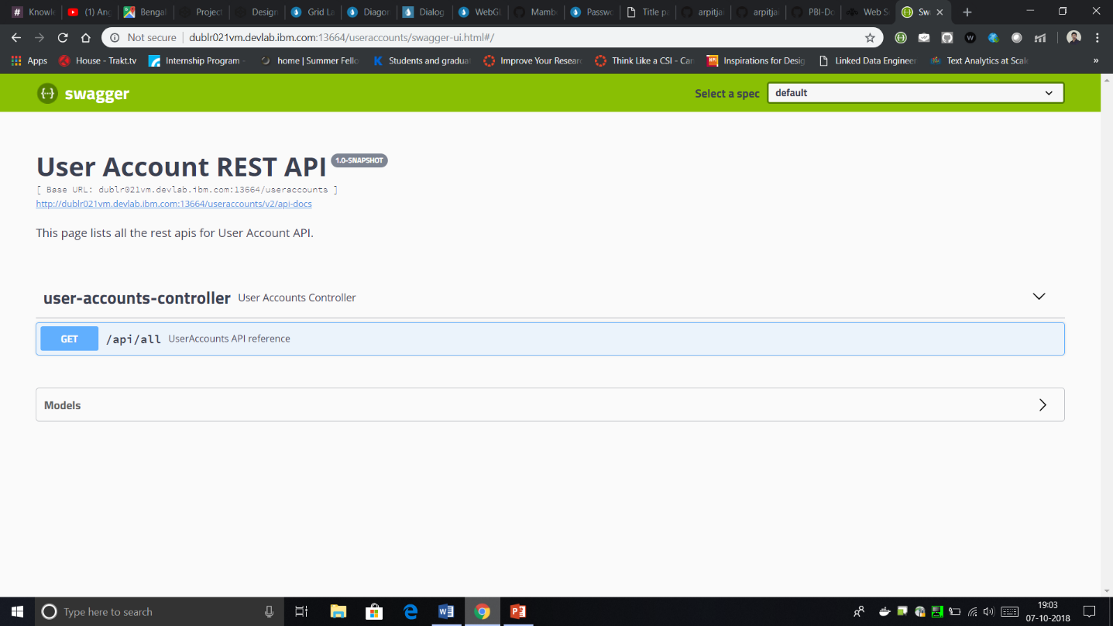Task 4: Adding Swagger Hub Documentation Dependency

Task 5: Adding UI using Angular JS to SpringBoot APIs

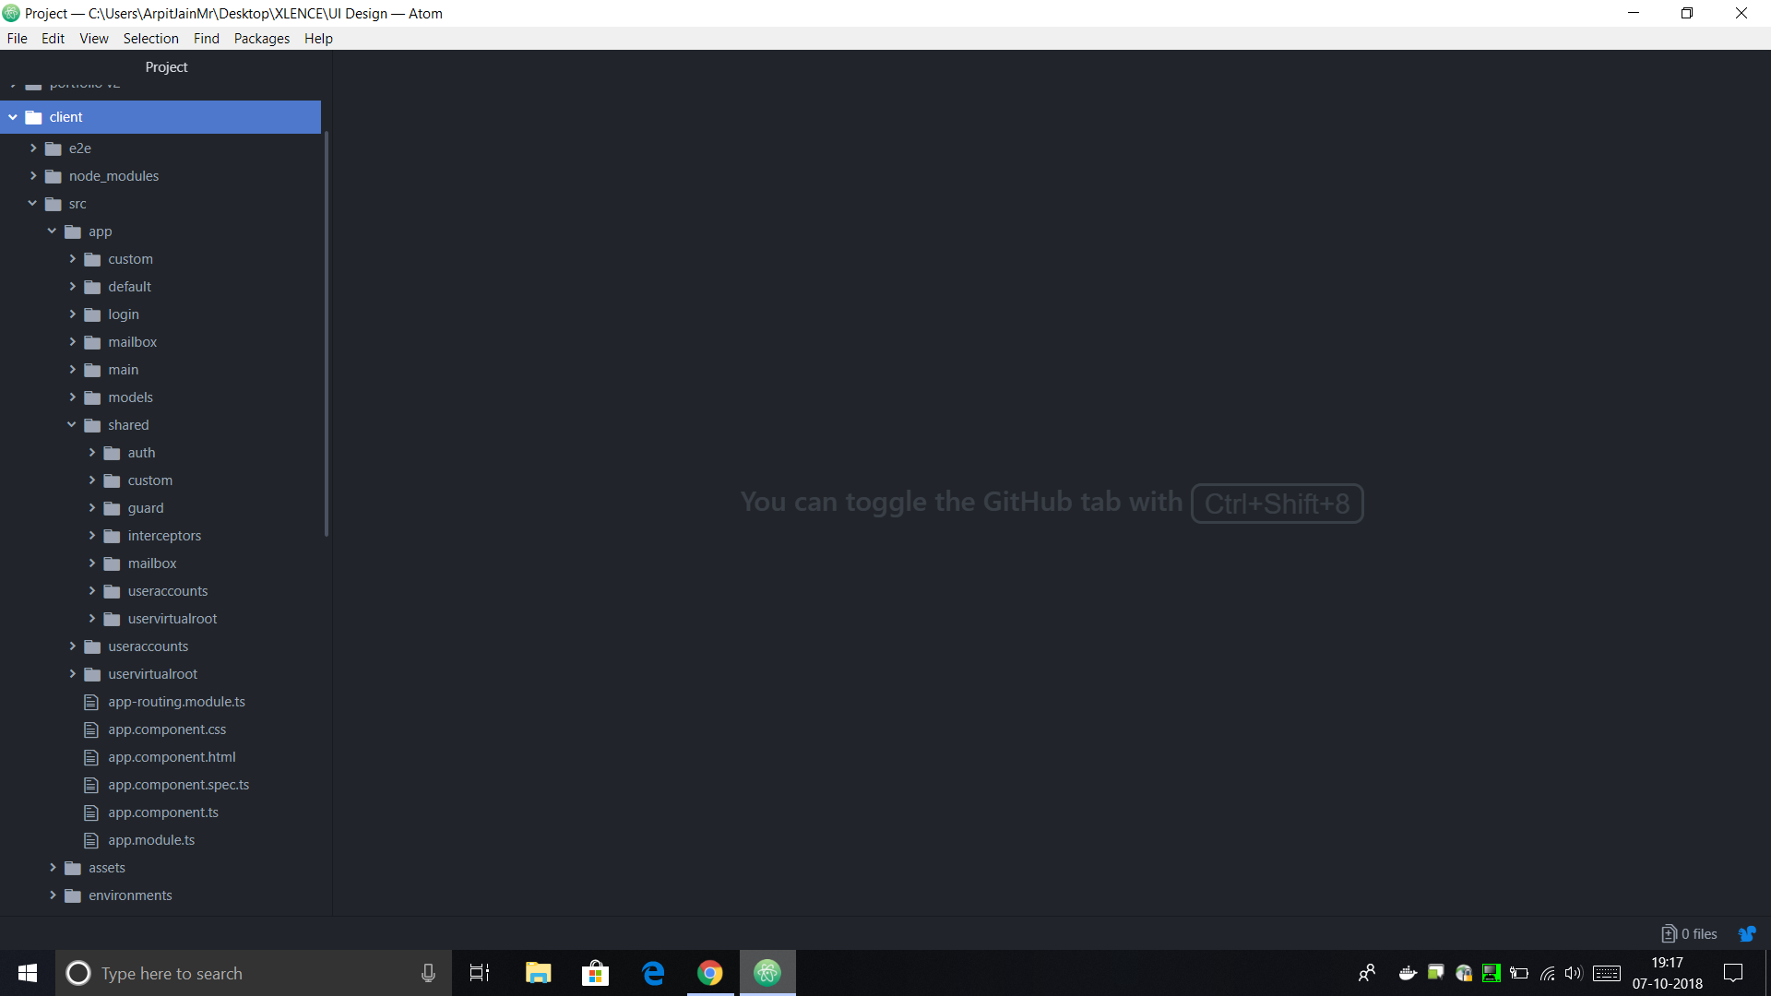

Now, the next task was to add the UI to the newly created APIs.

I chose Angular JS for this because it has large community support and is extremely modular. It uses a Language called Typescript (by Microsoft) for code.

On the right, is the Angular Code Structure. Following are the UI screen snaps for the REST API client we created using Angular.

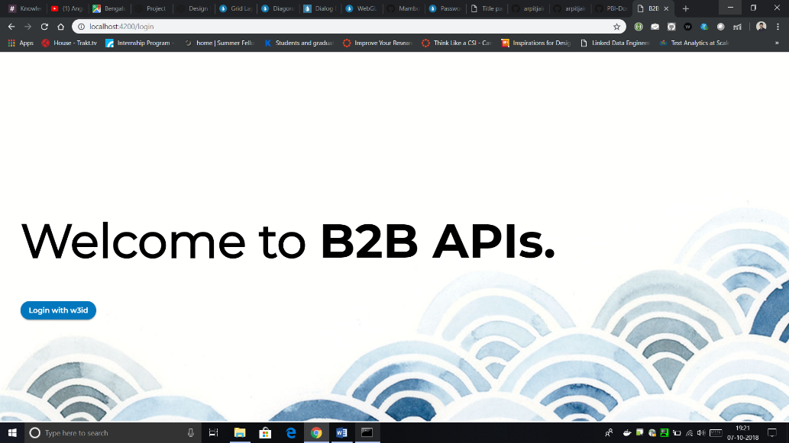On the Login page, user needs to click on the Login with w3id Button to be authenticated with his/her IBM ID.

# [[Link]](http://159.122.187.184:30070)

The above UI was deployed as a microservice separate than the Backend Spring based API Gateway on IBM Cloud Kubernetes Cluster by building it as a docker image.

Following is the flow diagram of the Entire Work until now.

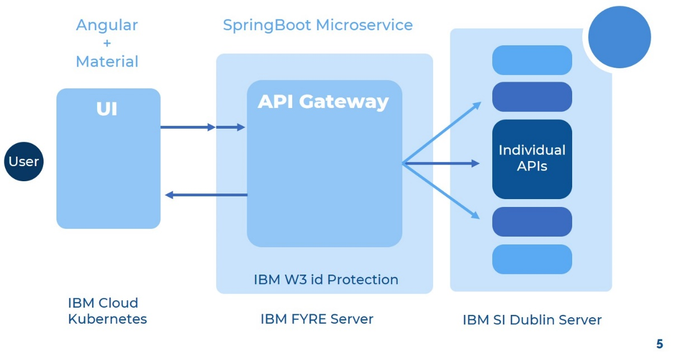

Task 6 (Apart from the main work): DFRAME Docker deployment framework

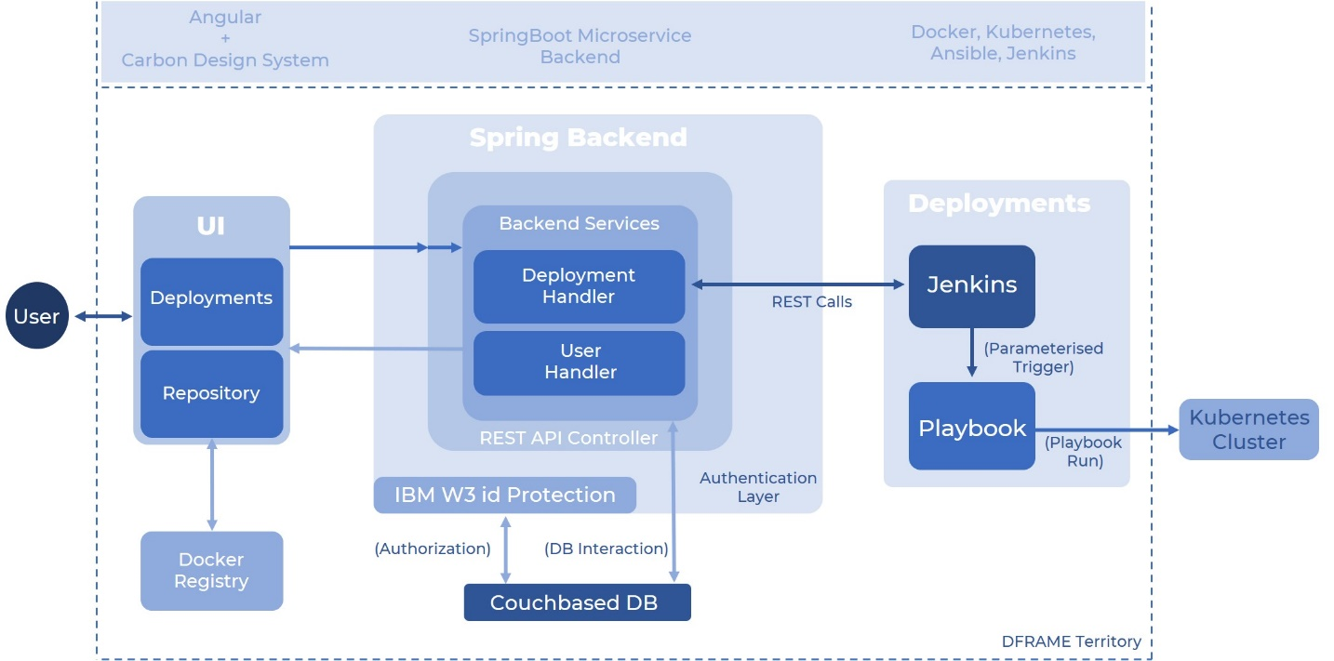As a part of the XLence Program for the IBM interns, we developed a Docker image deployment framework that builds and deploys an Application Image in just a few clicks from the intuitive UI. Following figure will illustrate the exact functioning and architecture of this application.

These are UI Flows for this application.

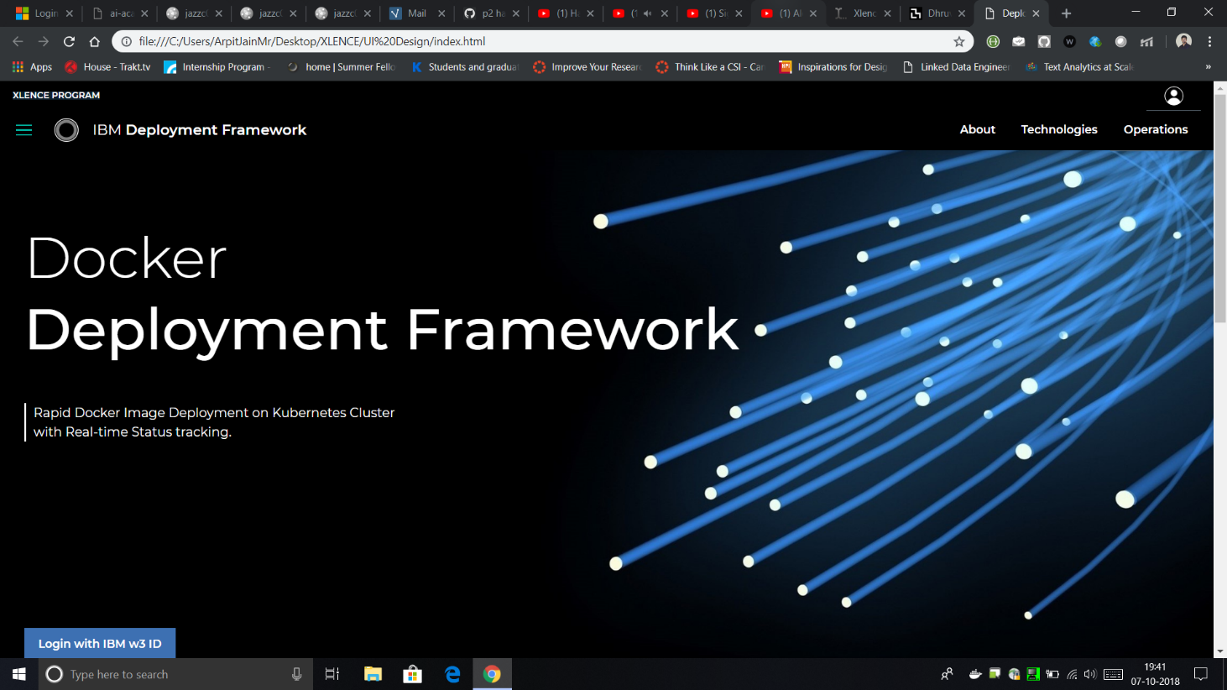

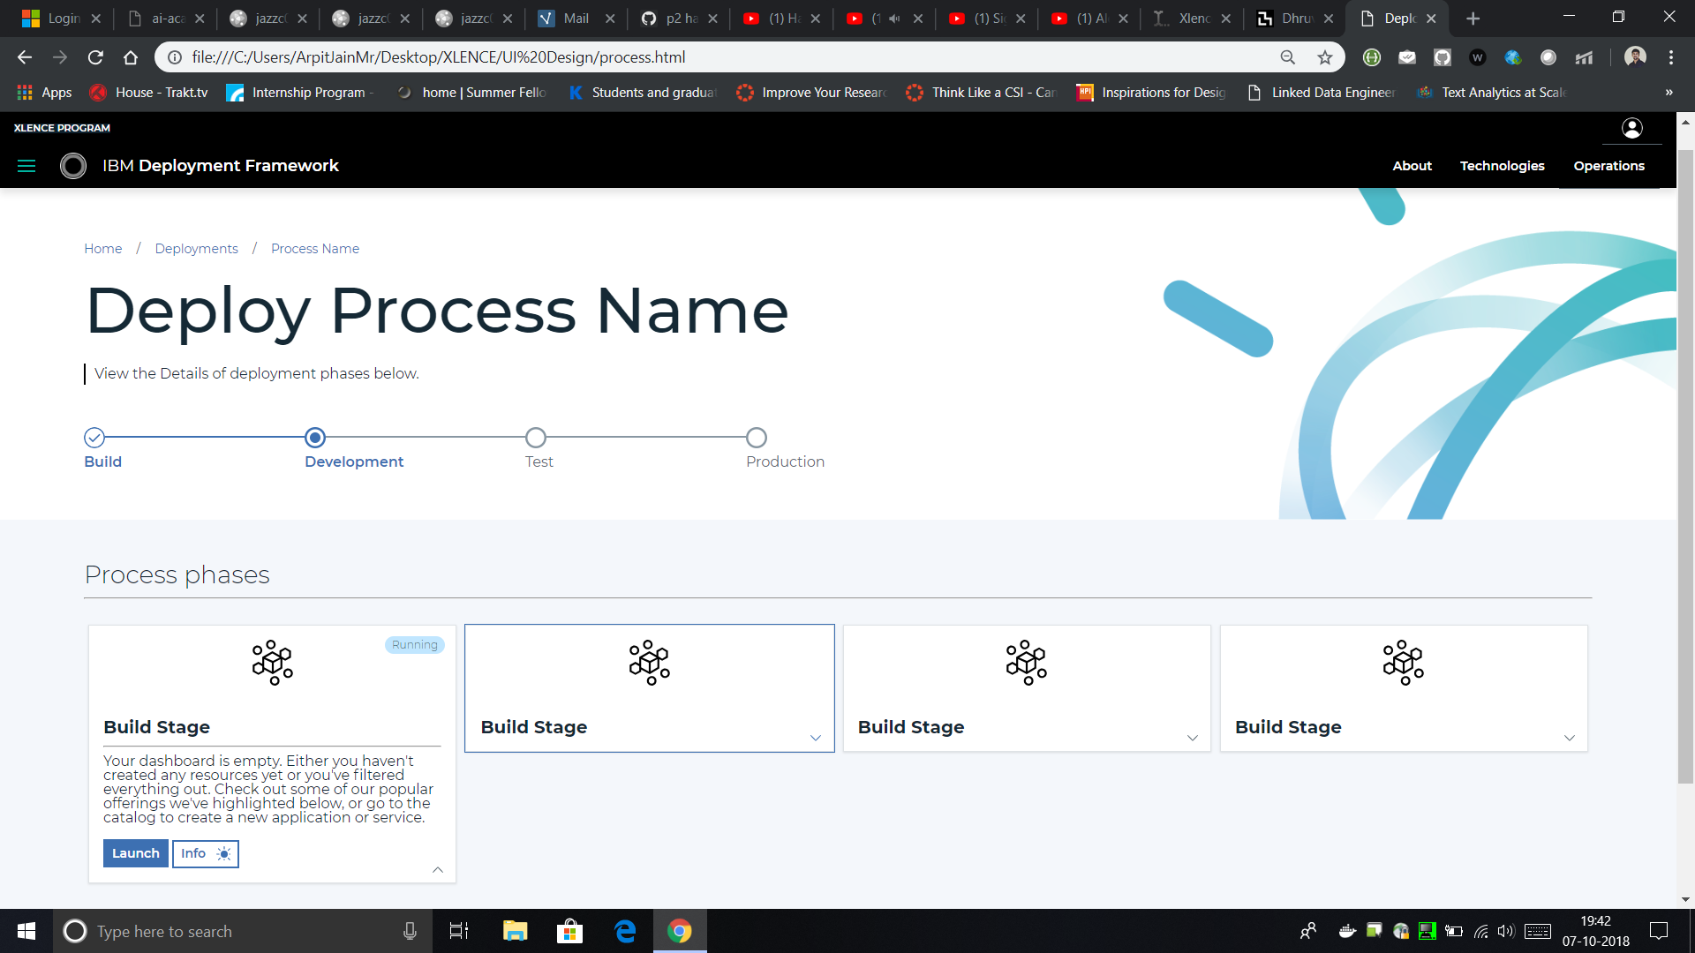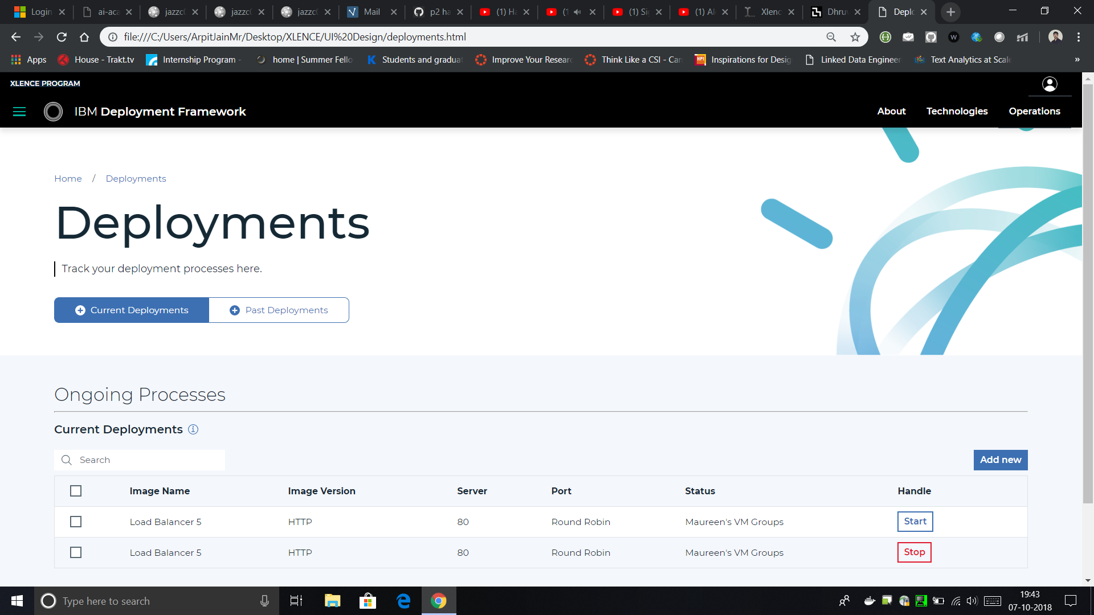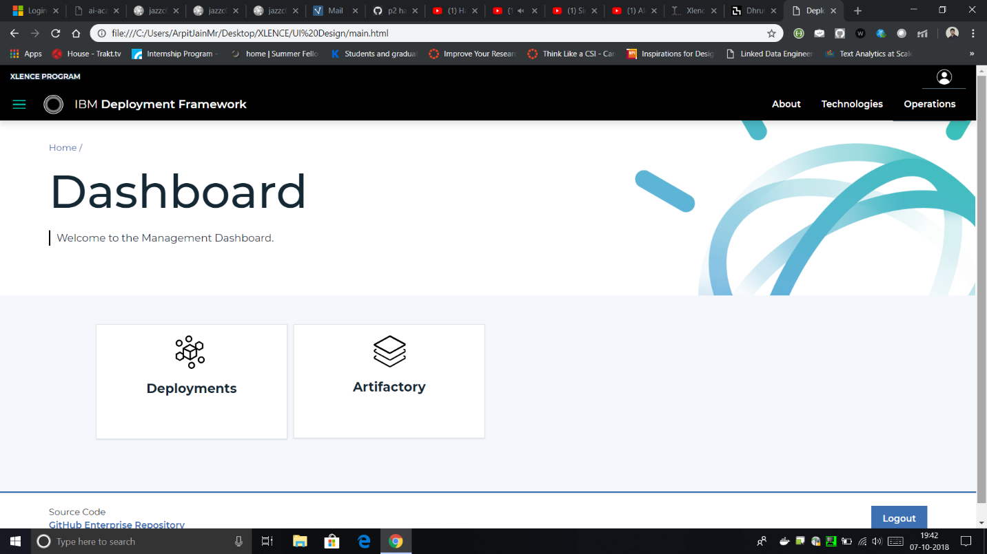

# Results and Discussions

Microservices are an effective and fault-tolerant manner of designing and developing an application. The heart of B2Bi is composed of several business processes which are used to automate the operation of B2B services (Mailbox, Invoice, Order; etc). By using REST APIs, you can perform certain B2B functions using Sterling B2B Integrator. B2B REST APIs were released starting with Sterling B2B Integrator V5.2.6.1. These Rest APIs were built using core Java and IBM TenX framework.

IBM and Sterling team is exploring about some alternative frameworks for converting these APIs which would make the execution of calls faster. Separate microservices can be deployed on the B2B SI platform server to enhance its functionality. During this duration, I transformed few of the B2B APIs to the SpringBoot framework to demonstrate to the team the potential performance improvement. All B2B APIs currently come packaged as a single WAR file. So, I took the goal to convert all these bundled APIs into separate Spring microservices and deploy them distinctively too.

# Conclusions

During past few weeks, I was involved in converting a few B2B APIs like UserVirtualRoot and UserAccounts to Spring Boot Rest API Framework and deploy it in the form of a WAR file on the liberty server of the Sterling Integrator. All the IBM B2B APIs are currently built over the IBM TENX framework that is slow in function as it has useless layering of procedure calls. My team wants to test if converting these APIs to Spring Boot framework will make them faster in execution. For this purpose, currently I am assigned for POCs (Proof of Concept). In this report I have also shown the performance improvement by using the SpringBoot framework over the normal TenX. It is nearly 12 times faster for bulk level calls. This is a huge improvement. My team will consider pitching this idea to the stakeholders and then eventually converting all the B2B APIs to SpringBoot. Customers will also be excited about this speed and performance improvement.

**Next Target**

Since this POC of proving that SpringBoot is faster than TenX is done, my target for the next 15 days is to create a new service for Sterling Integrator – JSON/XML Transformer. This will allow the customers to use inbuilt XML/JSON service for their data conversion needs. Also, I would need make the Rest API client service (Pre-Midterm) more production ready as it is going to be passed to the QA (Quality Assurance) stage for final testing.